Name

Mathematics Advanced Year 11
Reciprocal Functions

Book 1 |  | Version: 261015  Feedback:  https://MrDingMaths.com
Contents
Syllabus Content 2
Learning Intention 3

Syllabus Content
Reciprocal functions
- Graph functions of the form $f(x)=\frac{k}{x}$, where $k$ is a constant and $k≠0$, and identify their hyperbolic shape and their asymptotes
- Describe the behaviour of $f\left(x\right)=\frac{k}{x}$ as $x→∞$ and $x→-∞$

Hyperbolas

- Reciprocal Relationships
Reciprocal relationships are in the form $y=$ $\frac{k}{x}$.
Their graph will not be a straight line; so the relationship is non-linear.
We can graph reciprocal relationships using these steps:
  - Construct a table of values using the equation.
  - Graph the table by using the columns as coordinates.
  - Join the points to form a smooth curve.

- Investigation Graph reciprocal relationships using a table of values
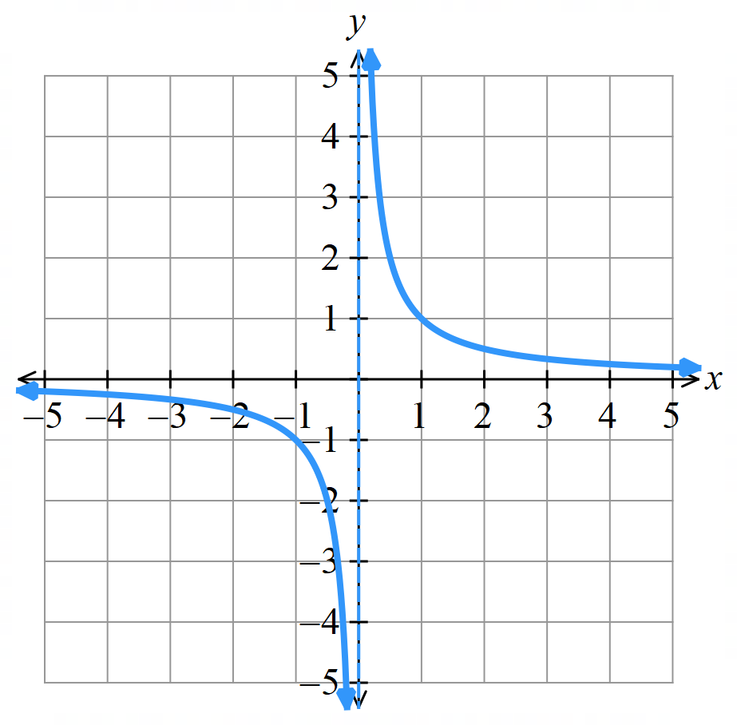
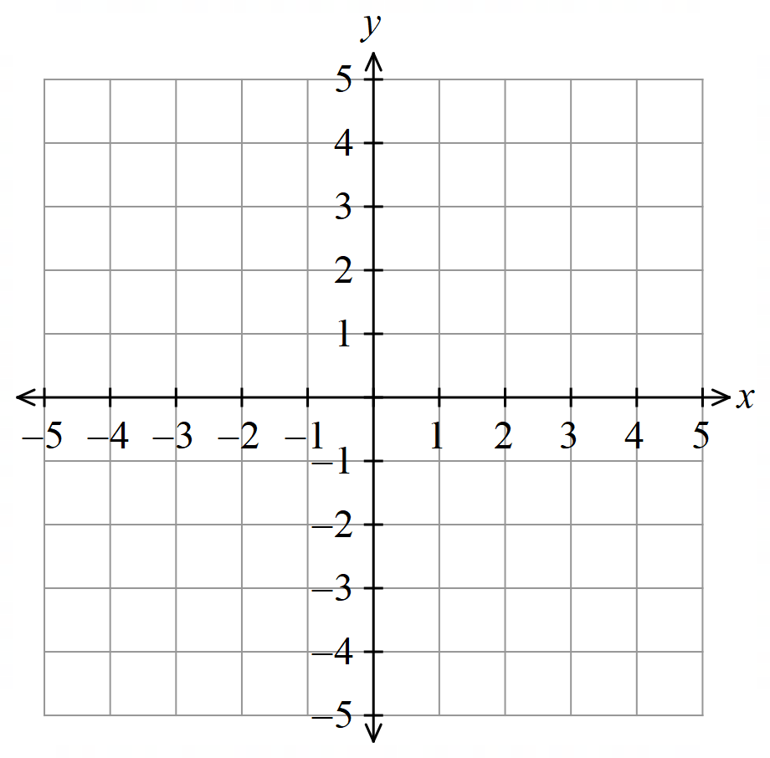
Draw the graph of $y=$ $\frac{1}{x}$
$$x$$ | $$-2$$ | $$-1$$ | $$-\frac{1}{2}$$ | $$0$$ | $$\frac{1}{2}$$ | $$1$$ | $$2$$
$$y$$

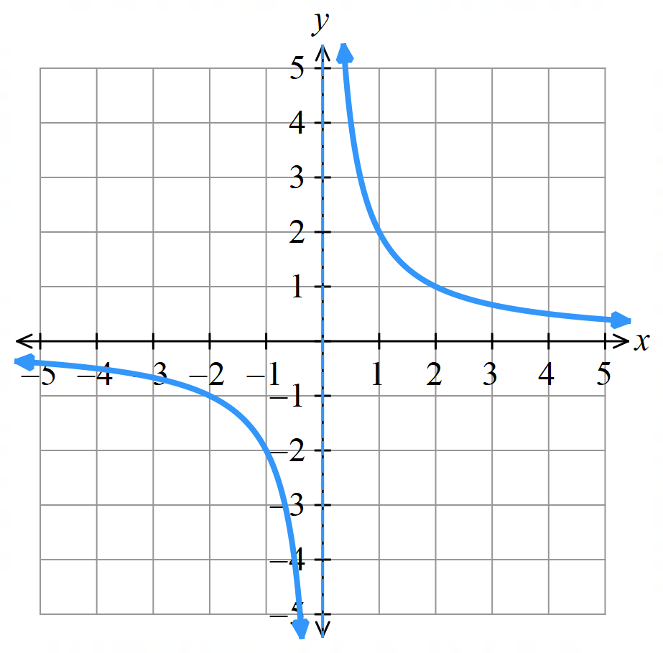
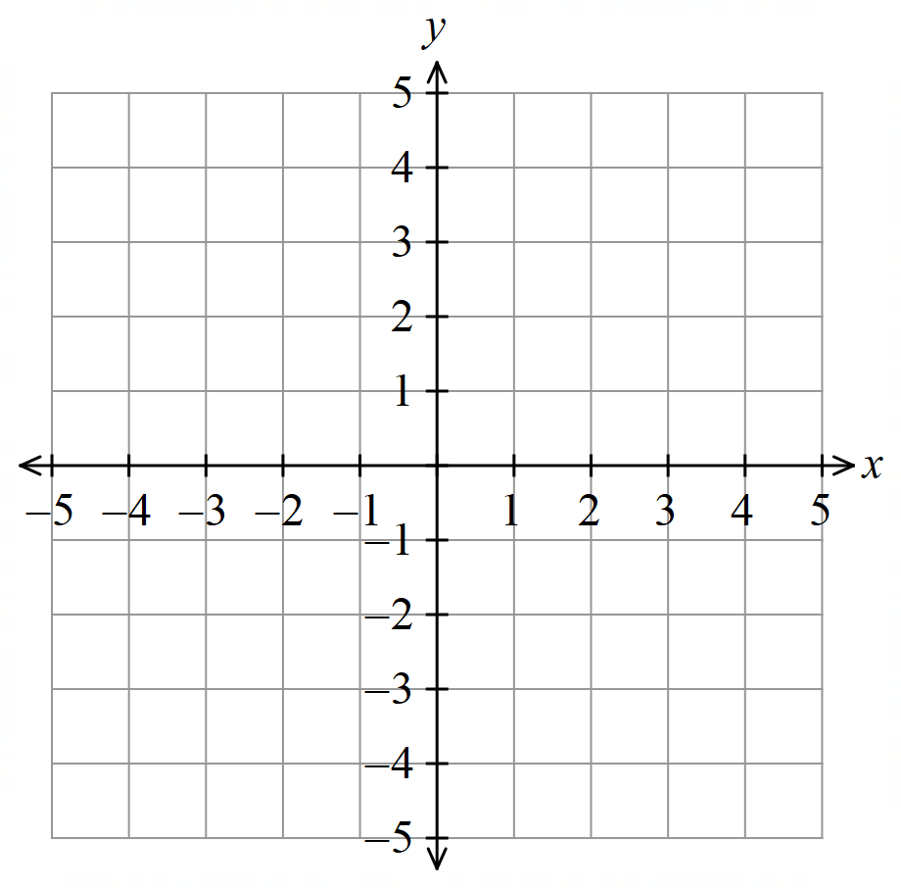
Draw the graph of $y=$ $\frac{2}{x}$

$$x$$ | $$-2$$ | $$-1$$ | $$-\frac{1}{2}$$ | $$0$$ | $$\frac{1}{2}$$ | $$1$$ | $$2$$
$$y$$

- Properties of Hyperbolas
A reciprocal relationship $y=$ $\frac{k}{x}$ has a graph in the shape of a hyperbola.
Hyperbolas have:
- Two asymptotes: lines where the graph approaches but never reaches.
- No $x$ or $y$-intercepts.
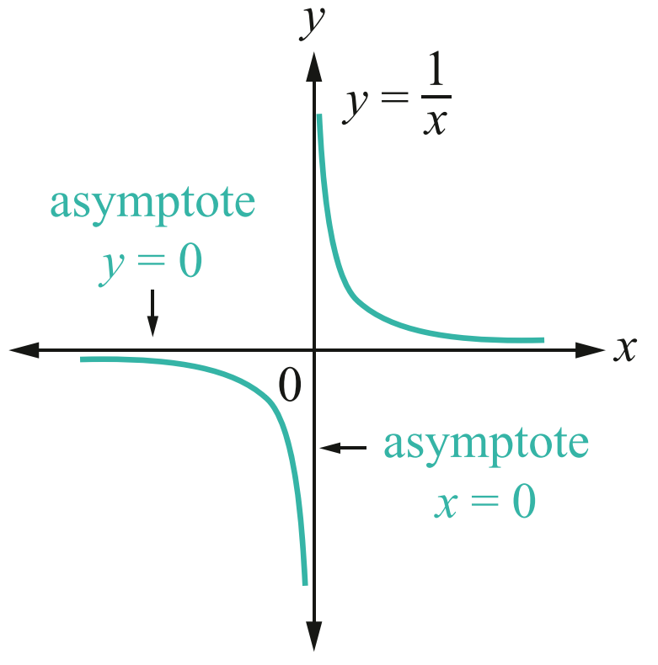
- Two symmetrical branches.

- Identify Features of hyperbolas
- $y=$ $\frac{2}{x}$  Identify the asymptotes.  Behaviour as $x→∞$:  Behaviour as $x→-∞$:  Behaviour as $x→0^{+}$:  Behaviour as $x→0^{-}$: | - $y=-$ $\frac{2}{x}$  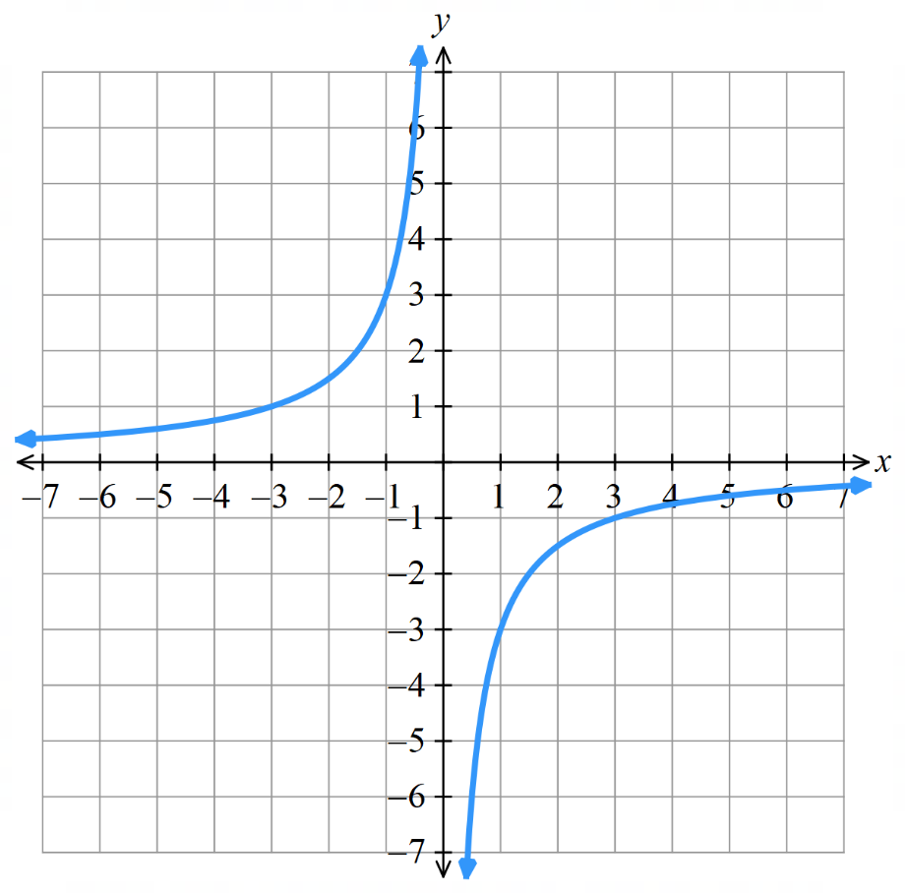  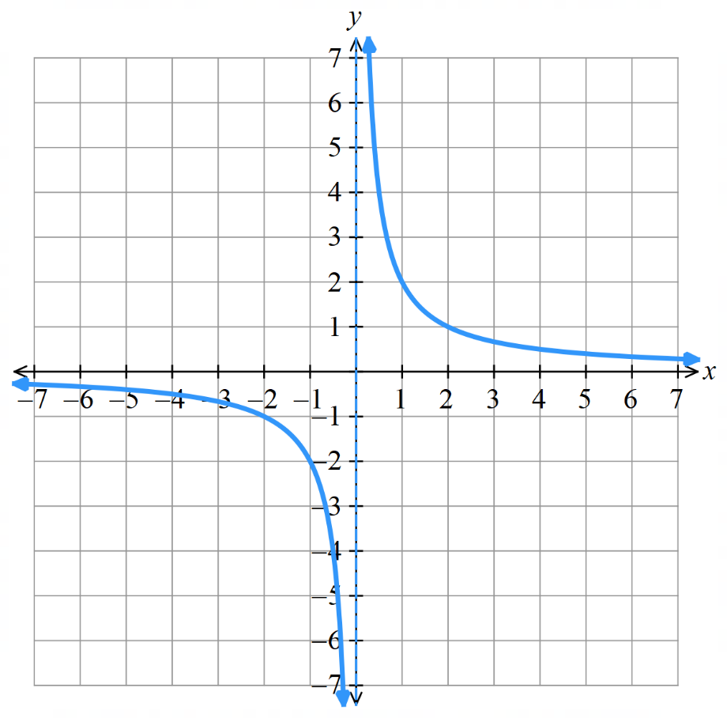  Identify the asymptotes.  Behaviour as $x→∞$:  Behaviour as $x→-∞$:  Behaviour as $x→0^{+}$:  Behaviour as $x→0^{-}$:
- Investigation Equation and the graph of a hyperbola
- https://www.desmos.com/calculator

- Sketch these graphs  $y=$ $\frac{1}{x}$  $y=$ $\frac{2}{x}$  $y=$ $\frac{3}{x}$  $y=$ $\frac{4}{x}$  Increasing the value of $k$ s………………… or dilates the hyperbola away from the axes. | - Sketch these graphs.  $y=$ $\frac{-1}{x}$  $y=$ $\frac{-2}{x}$  $y=$ $\frac{-3}{x}$  $y=$ $\frac{-4}{x}$  A negative value of $k$ means the hyperbola is in the …………… and …………… quadrants.
- Sketch these graphs  $y=$ $\frac{1}{x}$ $+1$  $y=$ $\frac{1}{x}$ $+2$  $y=$ $\frac{1}{x}$ $+3$  $y=$ $\frac{1}{x}$ $-3$  $y=$ $\frac{1}{x}$ $-4$  The constant term shifts the hyperbola v……………………… | - Sketch these graphs  $y=$ $\frac{1}{x+1}$  $y=$ $\frac{1}{x+2}$  $y=$ $\frac{1}{x+3}$  $y=$ $\frac{1}{x-3}$  $y=$ $\frac{1}{x-4}$  The constant term with the $x$ shifts the hyperbola h………………………

- Hyperbola Transformations
Consider the equation of a hyperbola $y=$ $\frac{k}{x-b}$ $+c$, where $k$ is an integer.
The parameters $k,b, c$ are numbers that affect the graph in predictable ways.
$k$ is positive, the hyperbola is top …………… and bottom …………… relative to the asymptotes.  $$y=\frac{1}{x}$$ | $k$ is negative, the hyperbola is ……………… and ………………… relative to the asymptotes.  $$y=-\frac{1}{x}$$  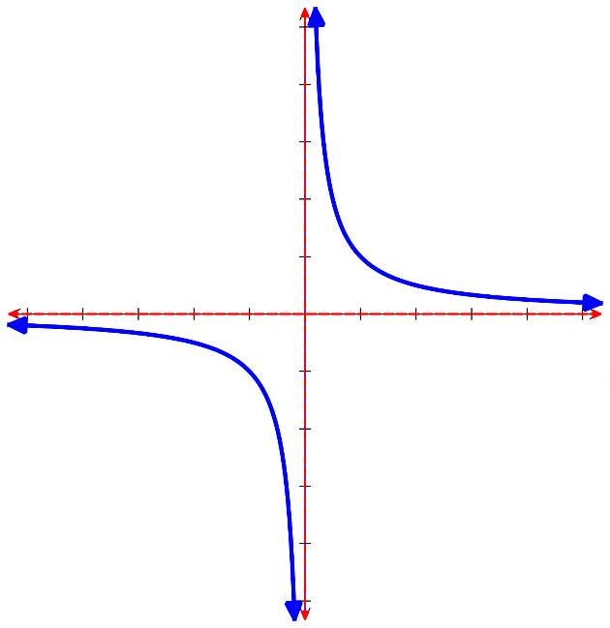  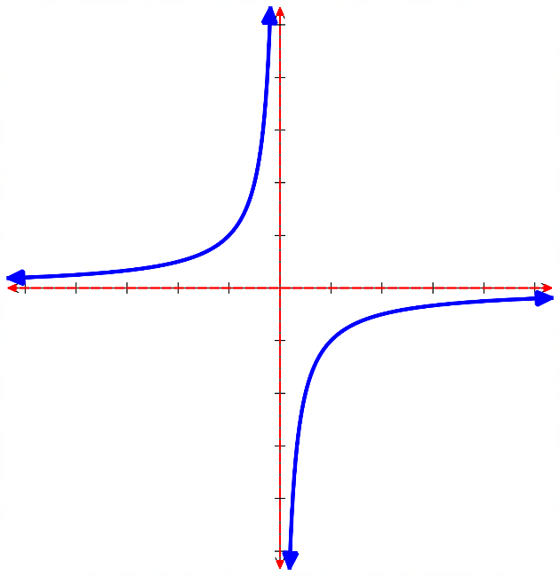
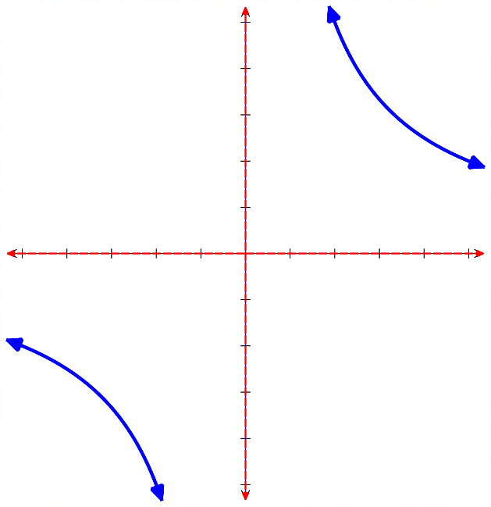
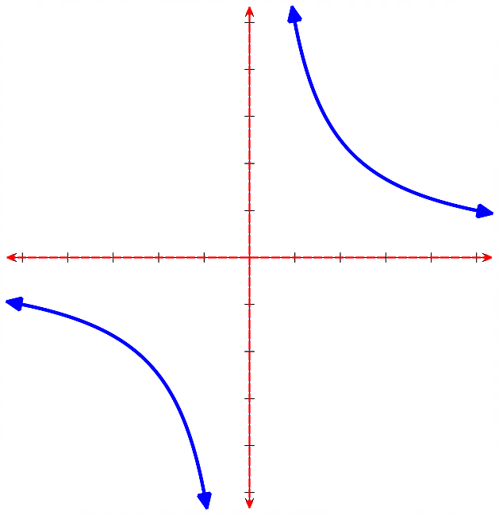
As $\left|k\right|$ increases, the hyperbola gets dilated; it stretches away from the axes.
$y=$ $\frac{5}{x}$ $y=$ $\frac{10}{x}$

$c$ shifts the curve …………………. The value of $c$ is the …………… asymptote.
$y=$ $\frac{1}{x}$ $+2$ $y=$ $\frac{1}{x}$ $-2$
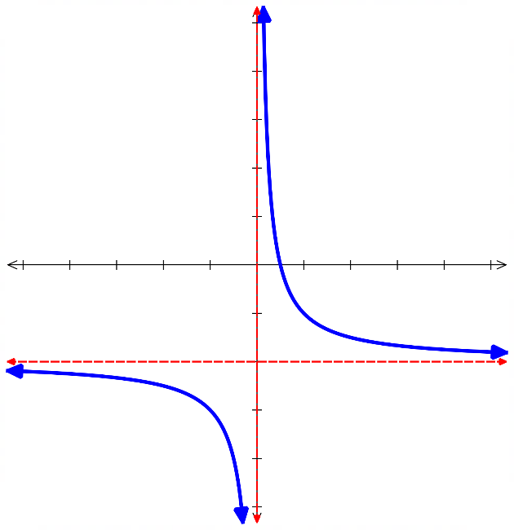
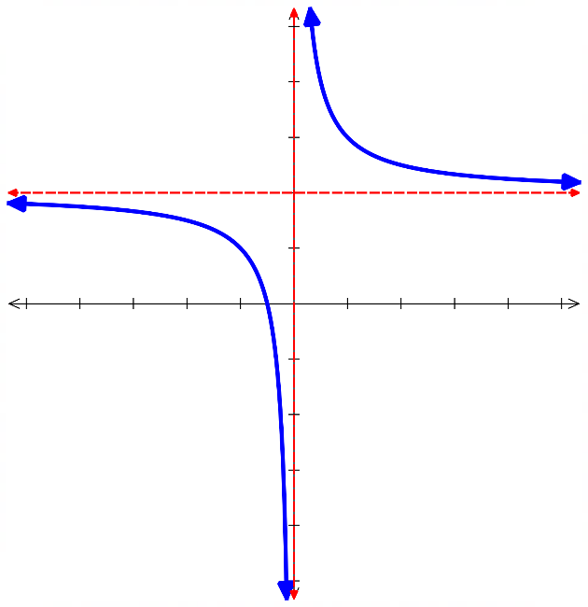

$b$ shifts the curve ………………… The value of $b$ is the …………… asymptote.
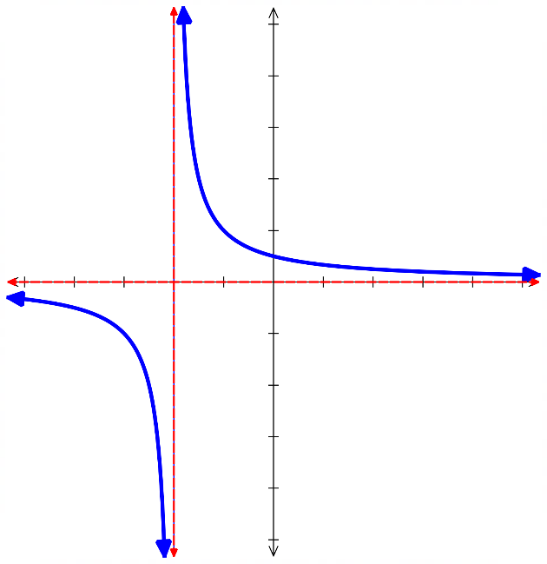
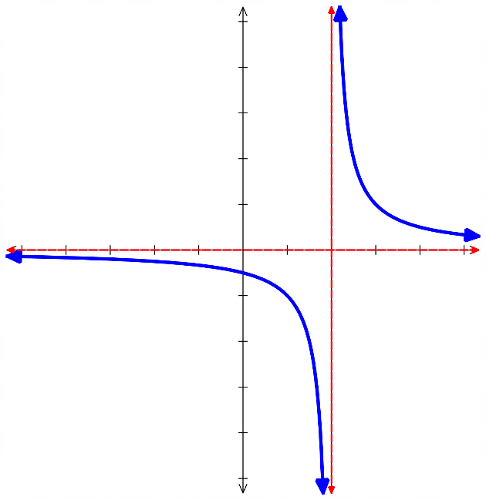
$y=$ $\frac{1}{x-2}$ $y=$ $\frac{1}{x+2}$

- Sketching Hyperbolas
Dilates, or stretches, hyperbola

$$y=\frac{k}{x-b}+c$$

Horizontal translation Vertical translation
$x=b$ is a vertical asymptote $y=c$ is a horizontal asymptote
To sketch hyperbolas:
- Find $y$-intercept, if any, by letting $x=0$.
- Find $x$-intercept, if any, by letting $y=0$.
- Find vertical asymptote at $x=b$ and horizontal asymptote at $y=c$,

- Example Sketch hyperbolas, showing intercepts and asymptotes
$y=$ $\frac{1}{x+1}$ $+2$  1. $y$-int: Let $x=0$,  $y=\frac{1}{1}+2=3$  2. $x$-int: $Let y=0$  $$0=\frac{1}{x+1}+2$$  $$-2=\frac{1}{x+1}$$  $$-2x-2=1$$  $$-2x=3$$  $$x=-\frac{3}{2}$$  3. Asymptotes: $x=-1$  $y=2$  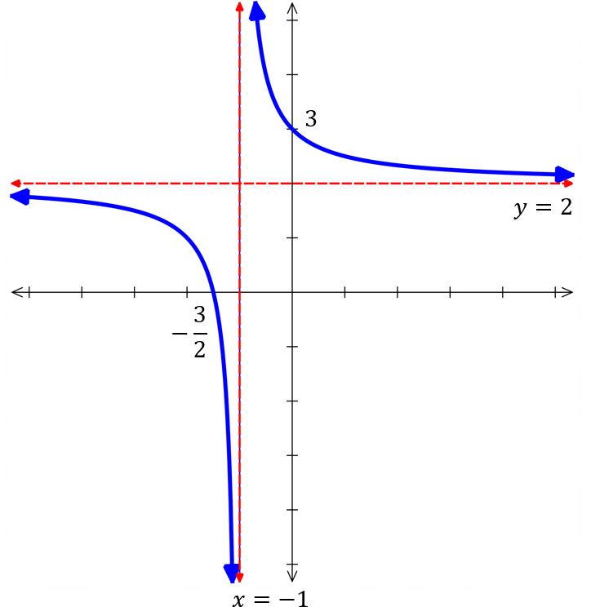  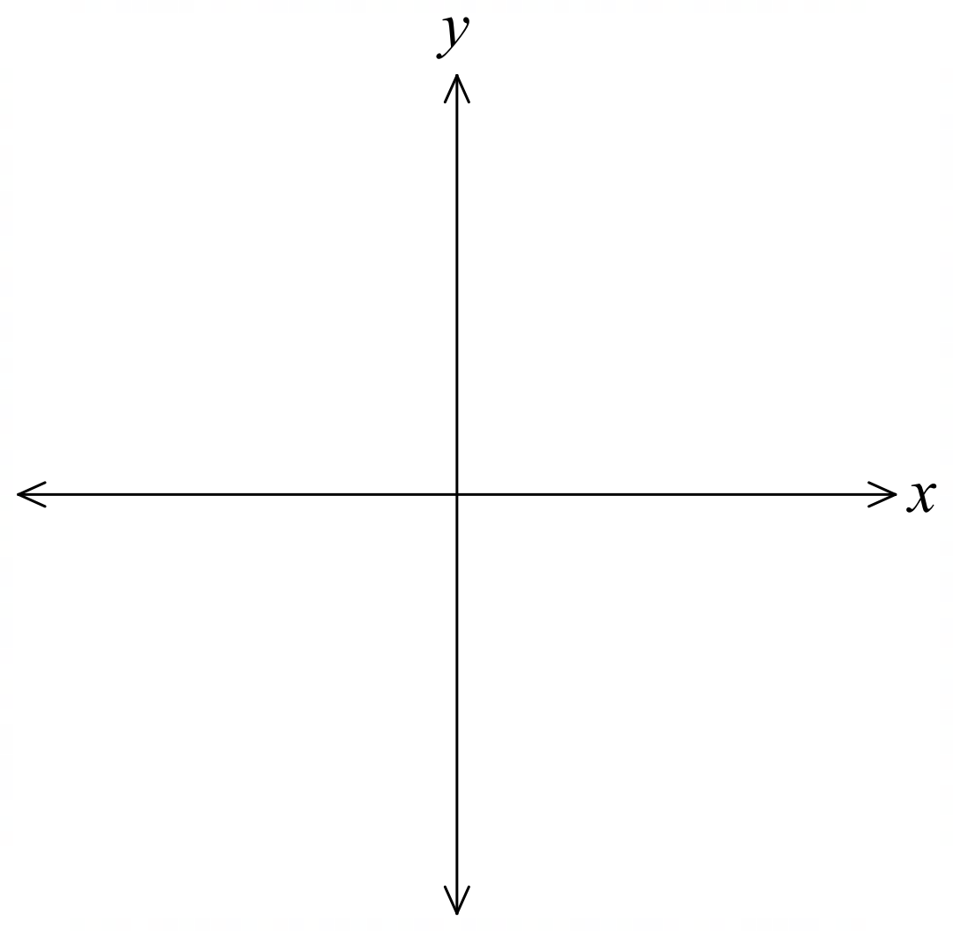 | 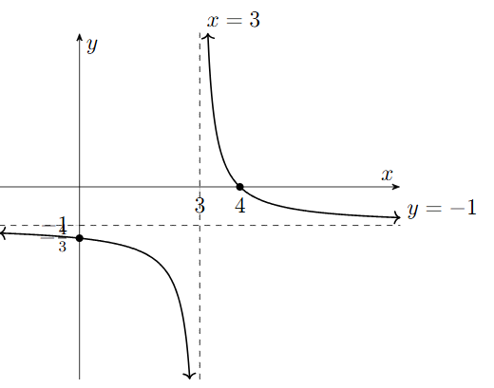  $y=$ $\frac{1}{x-3}$ $-1$

- Alternate Form of a Hyperbola
Another form of a hyperbola is
$$y=\frac{px+q}{rx+s}$$

We can convert this to the standard form by splitting the numerator.

- Example Sketch hyperbolas in alternate form.
$y=$ $\frac{2x+3}{x-1}$  0. Convert to standard form  $$y=\frac{2x+3}{x-1} \\ =\frac{2x-2+2+3}{x-1} \\ =\frac{2x-2}{x-1}+\frac{5}{x-1} \\ =2+\frac{5}{x-1}$$  1. $y$-int: Let $x=0$,  $y=2+\frac{5}{-1}=-3$  2. $x$-int: $Let y=0$  $$0=2+\frac{5}{x-1}$$  $$-2=\frac{5}{x-1}$$  $$-2x+2=5$$  $$-2x=3$$  $$x=-\frac{3}{2}$$  3. Asymptotes: $x=1$  $y=2$  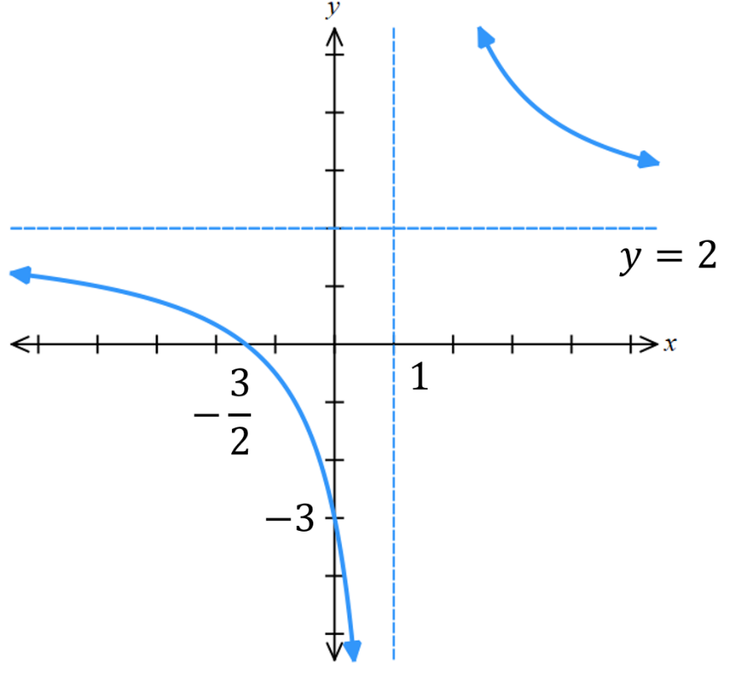 | 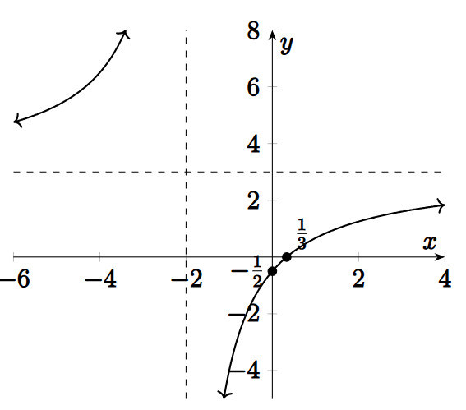  $y=$ $\frac{3x-1}{x+2}$

